Interview Question for position QA

1. **Manual Test Question**

* Given scenario that during testing you found these bugs:
  + User unable to access topdanmark website
  + User unable to login to topdanmark system
  + Login button is not in the right position which should be at top left of the website
  + Topdanmark website is not using https

1. Base on your analysis, how you prioritize the bugs based on severity

**Answer:**

* + Topdanmark website is not using https: Severity 1 (highest), since the traffic is not encrypted, and it could be a serious security flaw.
  + User unable to access Topdanmark website: Severity 2. The whole site or system could be down hence users cannot visit and perform their tasks/view latest information etc.
  + User unable to login: Severity 3. User can still access the website, but just could not login.
  + Login button is not in the right position: Severity 4 (Lowest). Since this is only a UI issue, and if it’s not hindering the button functionality then it should have the lowest priority.

1. If the developer feedback stated that the bug can’t be fix during the current sprint, what will you do

**Answer:**

* Fix the highest priority bug first if possible. Bring that matter during next sprint planning, break down the task and estimate them so that it can be fixed during the next sprint, or to determine what is the next action that the team need to take.
* Given Scenario:

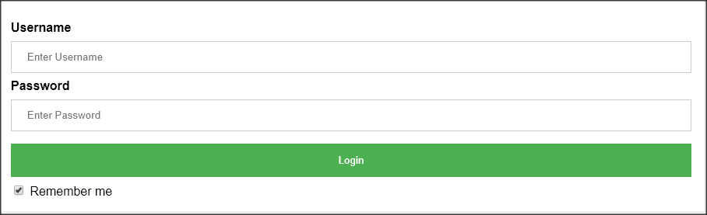

* 1. Create as many test script as you can

**Answer:**

* login with valid username and password
* login with valid username and invalid password
* login with invalid username and password
* login with invalid username and valid password
* login with an invalid username that has special characters in them
* login with valid username and password while checking on the remember me button
* after logout check whether the credentials are saved in the username and password fields
* use a performance testing tool to test the performance of the login page by having a few virtual users accessing the page at a given time
  + - load test
    - stress test
  1. What type of testing approach that you going to use

**Answer:**

* test as early as possible during the development
* create unit tests for the login page
* automate the UI test of the login page
* create performance test for the login page (load/stress test) to see how it behaves under heavy load

1. **Technical Test Question**

* By using Selenium, we would like you to create simple automation with following scenario (You can post your source code into any online repository):
  + To Ensure that when I search keyword “topdanmark” at google, the first record that is displayed to me is not other than “topdanmark”
  + To ensure that I can access <https://www.topdanmark.dk> from various browser (i.e. IE, Chrome, etc)
* What is API and what type of API that you know with the difference among them

**Answer:**

* + Stands for Application Programming Interface, it serves as an interface between 2 applications
  + There are:
    1. Remote API. Eg: JDBC
    2. Web API. Eg: REST
* What type of testing you can do when dealing with project that use API

**Answer:**

* + Unit testing – test for a specific component or individual operation
  + Functional testing – test the functionality, can include regression testing as well
  + Load testing – validating functionality and performance under load
  + Security testing – penetration test, validating authentication, encryption
  + UI testing – validate GUI in broader scope